Geography 028
Many flags of European countries have three stripes, vertical or horizontal - how many of the following do you know?

(vertical stripes left to right - technically first colour is the one at the 'hoist', i.e., nearest the flagpole)
1. black/yellow/red | 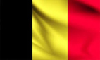
Answer
2. blue/white/red | 
Answer
3. green/white/red - Italy | 
Answer
4. green/white/orange | 
Answer

(horizontal stripes top to bottom)
5. red/white/green | 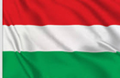
Answer
6. black/red/yellow | 
Answer
7. white/green/red | 
Answer
8. red/yellow/red | 
Answer
9. yellow/green/red | 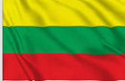
Answer
10. blue/black/white – Estonia | 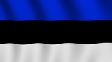
Answer
11. red/white/blue | 
Answer

Answers
1. black/yellow/red - Belgium
2. blue/white/red - France
3. green/white/red - Italy
4. green/white/orange - Ireland
(horizontal stripes top to bottom)
5. red/white/green - Hungary
6. black/red/yellow - Germany
7. white/green/red - Bulgaria
8. red/yellow/red - Spain
9. yellow/green/red - Lithuania
10. blue/black/white - Estonia
11. red/white/blue - Luxembourg, Netherlands (Holland)

